Time Tracking useful actions

Get Reports

For the moment it’s not possible to import the excel directly from the tool to our computer, so, first of all we have to generate it from the Administration View and then pull it to local.

Once the report is generated will be place in the /tmp folder of the node that contains the Application. They will be stored following the next pattern:
- For just one month: Monthly_Report_<month>_<year>.xlsx
For example: Monthly_Report_August_2019.xlsx
- For a period: Monthly_Report_<first_month>-<second_mont>_<year>.xlsx
For example: Monthly_Report_July-August_2019.xlsx

Then, we have to connect remotely to the node and pull it to local.
Through a command shell (we need to have previously installed the OpenShift Container Platform CLI) we connect to the platform:
$ oc login https://ocp.zurich.com

After introducing the credentials to log in we will have access to the node.
To download the report then we must run:
$ oc rsync <pod-name>:/tmp/<report-name> <local-path>
For example:
$ oc rsync timetrackingapp-1-hclsh:/tmp/Monthly_Report_August_2019.xlsx .

And it will download in the current folder.

Get into Data Base

The access to Openshift Platform will be done through https://ocp.zurich.com/console/

After login page we must go to Application Console from the superior tab like follows:
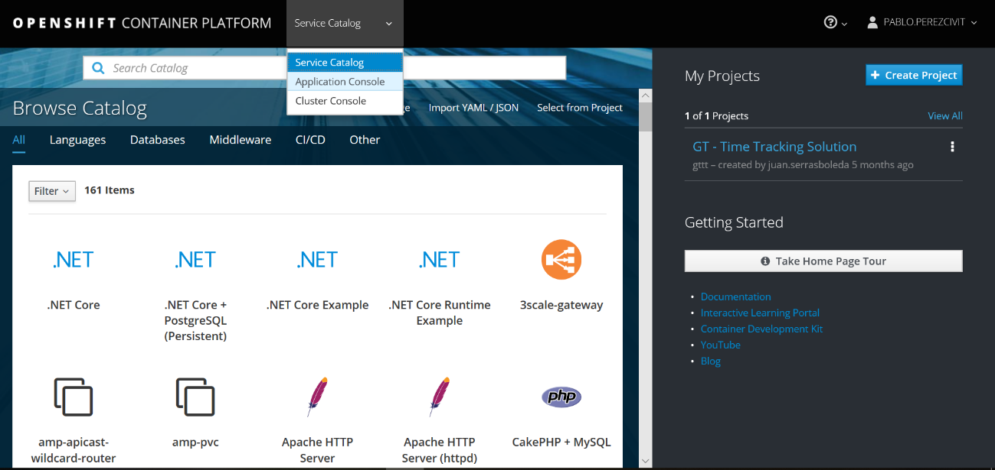

Here will be a list of the projects that we have. We click on GT – Time Tracking Solution
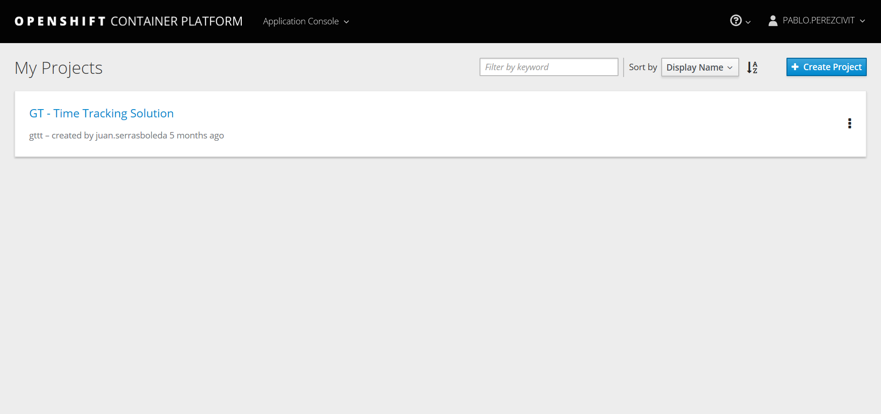

We get to the Overview page where we can see the different deploys we have.
To go to the Data Base node we’ll select from left panel Application -> Pods:
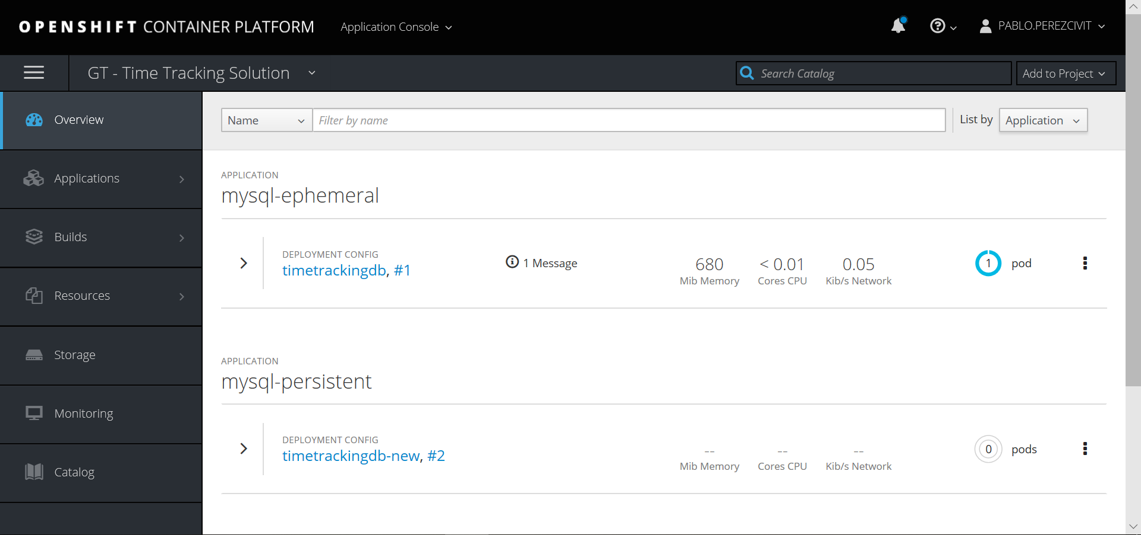

And the pods we’ll be displayed.
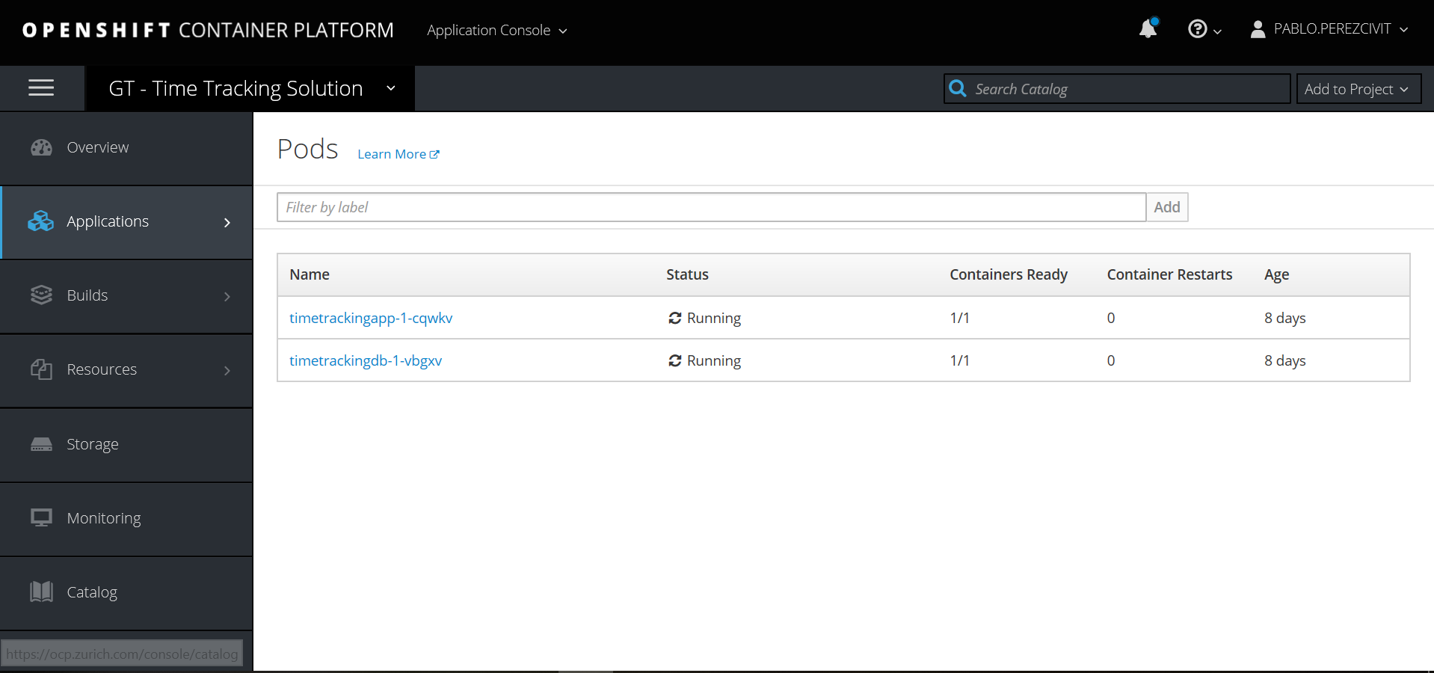
*The name extension can be different. For every new deployment it changes

Once we click on the data base pod we have different options.
To use the terminal just click on the tab:
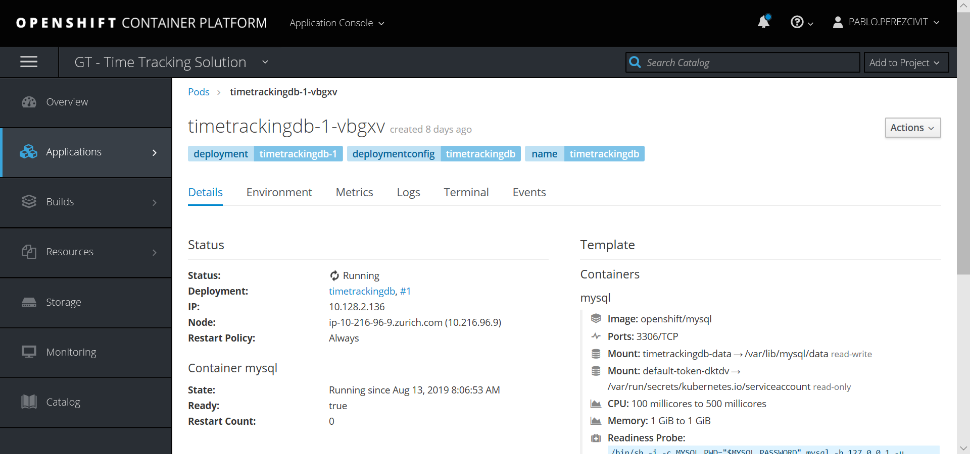

Now we are already have access by shell to the pod:
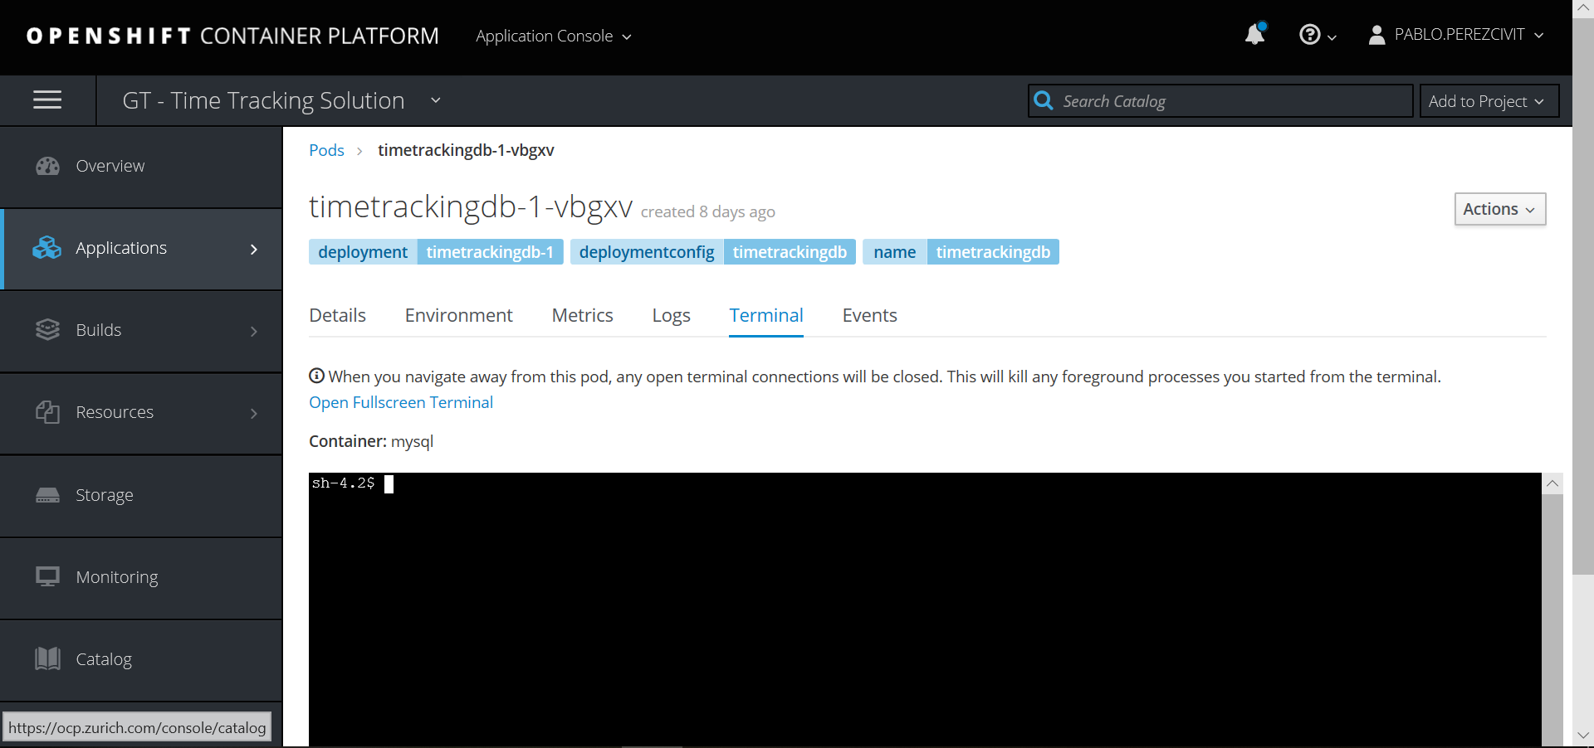

First of all, before connecting to Data Base, we have to export LANG to be able to see correctly the accents and other symbols from UTF-8
$ export LANG=en_US.UTF-8

If we want to check the changes, just run
$ locale

And the output should be something like this:
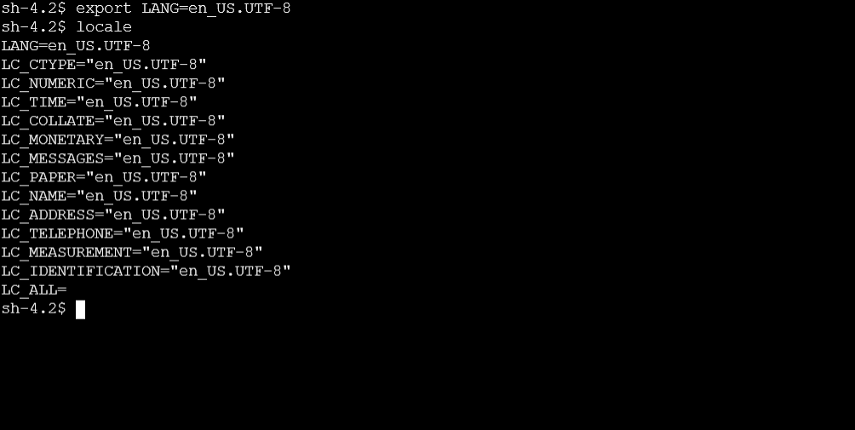

Then, connect to Data Base:
$ mysql -u pperezcivit -p
*It will prompt a password request

To select data base:
$ use time_tracking_db;

Now we can do whatever what we need related to data.

To generate backups

From Data Base terminal we have to run the following command:
$ mysqldump -u pperezcivit -p time_tracking_db > /tmp/backups/$(date +%Y_%m_%d)_time_tracking_db.sql
As we say, the backup file will be stored in /tmp/backups.
To download it to local, we should do something similar that we do with reports, but connecting to data base pod, not to the application one.

